Use-Case Realization Report
View Outline

Issue <1.0>
Revision History
Date | Issue | Description | Author
12/10/09 | 1.0 | Initial Version | Rajendran Kumaraguru

Table of Contents
1. Brief Description 4
2. Flow of Events 4
2.1 Standard Flow 4
2.2 Exception Flow 4
3. Interaction Diagrams 4
3.1 Collaboration Diagram for View Outline 4
4. Participating Objects 5
5. Class Diagrams 5
5.1 Class Diagram for View Outline 5
6. Derived Requirements 5

Use-Case Realization Report
View Outline

Brief Description
Portal admin will be able to fetch details for the created outline by using this view outline operation.

Flow of Events

Standard Flow
- Portal Admin login into the system.
- Portal admin clicks btnViewOutline()
- System loads outline Details
- System gets all outline details
- Validate the input fields data.
- Get the outline information from the entity
- Show the created outline detail to portal admin.

Exception Flow
  - If there is any error while validating the data then the respective exception will be thrown to portal admin.
  - If there is such outline exist then the error message will shown to portal admin.

Interaction Diagrams

Collaboration Diagram for View Outline
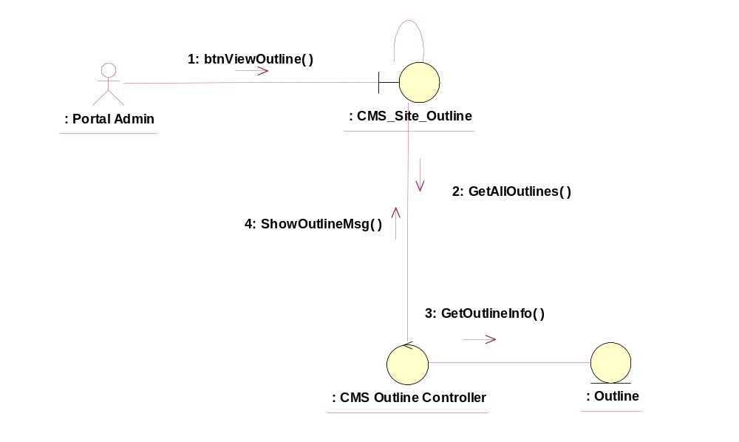

Participating Objects
CMS_Site_Outline
This object will be used for creating the outline.
: CMS Outline Controller
This is the controller to validate the files and duplicate check and creation of the outline..
: Outline
This is the object to store the outline info.

Class Diagrams

Class Diagram for View Outline
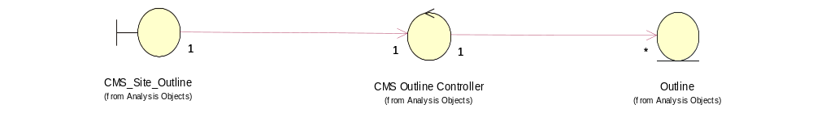

Derived Requirements
[enter the derived requirements here]

